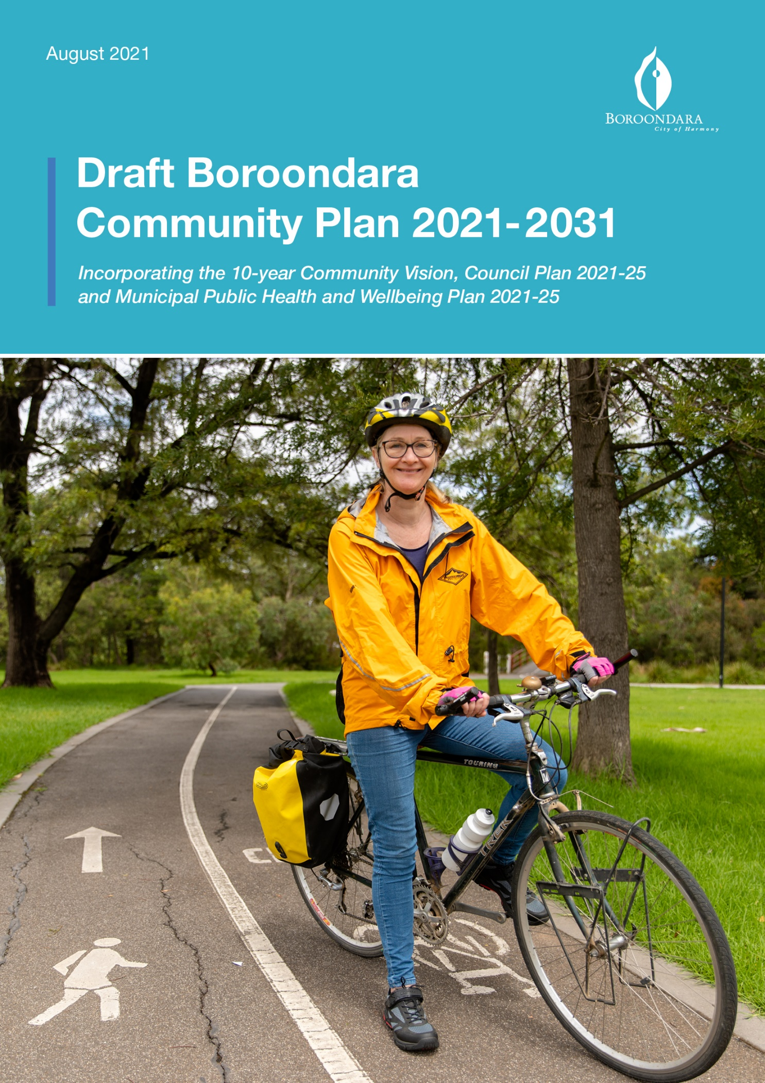

Contents
About the Plan 3
Our community’s vision 4
Preamble 5
Message from Councillors 6
Community snapshot 8
Our health and wellbeing 10
Renewing the Boroondara Community Plan 12
Boroondara Community Plan overview 15
Our wellbeing commitment 16
Theme 1: Community, Services and Facilities 18
Theme 2: Parks & Green Spaces 22
Theme 3: The Environment 24
Theme 4: Neighbourhood Character and Heritage 26
Theme 5: Moving Around 28
Theme 6: Local Economy 30
Theme 7: Leadership and Governance 32
Our health priorities 35
Implementing the Plan 37
Evaluating, refreshing and reporting on the Plan 38
Partnerships 39
Keeping in touch with the community 39
Councillors and wards 40
Appendix 1 - Responsibilities under the Public Health and Wellbeing Act 42
Appendix 2 - Municipal Health and Wellbeing Plan summary 43

Acknowledgement of Country
The City of Boroondara acknowledge the Wurundjeri Woi-wurrung people as the Traditional Owners and original custodians of this land, and pay our respects to their Elders past and present.

About the Plan
The (draft) Boroondara Community Plan 2021-31 (the Plan) sets out the 10 year vision for the City of Boroondara based on the aspirations of our community and the priorities they told us were important.
By renewing the inaugural Boroondara Community Plan 2017-27, the new Plan captures and responds to the changes in community priorities, which have occurred since the development of the Boroondara Community Plan 2017-27, and is reflective of the community’s experience during the COVID-19 global pandemic.
The Plan balances the needs of our community today, while recognising the challenges, opportunities and changes to come over the next decade.
Developed through a deliberative engagement process with our community, the Plan builds on what already makes Boroondara a great place to live, work, study and recreate. It paints a picture of what the community values most in the City of Boroondara and demonstrates how Council will practically bring our community’s vision to life, for the benefit of all community members.
The Plan incorporates the 10-year Community Vision, the Council Plan 2021-25 and the Municipal Public Health and Wellbeing Plan 2021-25, responding to Council’s requirements under the Local Government Act 2020 and the Victorian Public Health and Wellbeing Act 2008 (see Appendix 1).

Our community’s vision

A sustainable and inclusive community

When asked what they value most about Boroondara, our community described Boroondara’s unique attributes - our leafy neighbourhoods, parks and playgrounds, the heritage character of our streets and the relaxed and peaceful nature of the area. Meaningful community connections were valued as supporting a sense of safety, personal wellbeing and belonging for all.
Our community expressed how important it is for all community members, especially those in need, to be considered by Council in our planning, delivery, partnership and advocacy. They expressed a desire to ensure the features we enjoy in Boroondara are protected and enhanced for future generations. The community were clear we need to care for the environment, support sustainability and have a robust response to climate change.
Based on what our community told us they value most, the vision statement sets a common goal for Council and the community for the future of Boroondara over the next 10 years.
Cascading from this vision, the Plan details the community’s aspirations and priorities across seven themes and how Council will work together with our community and partners to deliver them.

Thank you
Councillors would like to thank and acknowledge every community member who has taken the time to tell us what is important to them in Boroondara. Thousands of community members right across Boroondara have provided their views through surveys, workshops, on the phone and online. These insights have been provided with such enthusiasm and passion for our community’s future.
Thank you also to our Council staff, local community groups, organisations and businesses who had an input and worked with our community to make sure as many voices as possible were heard to develop the Plan.

Preamble
After decades of relative stability and security, many of us have been overwhelmed by the recent pace of cascading and compounding health, social, economic and ecological change. This feeling has been brought home as we have seen rapid technological advancements, experienced an ongoing global pandemic and the effects of extreme weather events, including bushfires, floods and storms.
Over the next 10 years, we can build on the strengths and connections within our community, and those forged through the global pandemic, as we adjust to our changed conditions. Doing so will enable us to continue building our resilience to this increased pace of change.
Recently we have seen our households, families, neighbourhoods, communities, businesses and organisations band together, navigate uncertainty and pioneer new ways of doing things. We have looked out for each other, recognising the impacts of the pandemic have been experienced differently by members of our community. We have learned to innovate at home, in parks and open spaces, schools and workplaces, clubs, and via online apps and digital platforms. These will be the lessons we take forward, enabling us to navigate the global pandemic and thrive.
We will continue to see changes to the way we live, socialise, work, commute and connect in coming years. We recognise too, the real threat to our environment, to our health and wellbeing, and to the quality of life of current and future generations resulting from climate change. How we approach and respond to these changes will be what matters.
Focusing on the demands of today, while exploring the possibilities of tomorrow is an important balancing act. This means recognising and building on the rich history, heritage and community connections already present in the City of Boroondara, while continuing to embrace data, digital technology and innovative ways to resolve increasingly complicated problems. Most importantly, it requires us to work together: leading, learning, creating and sharing.
The Boroondara Community Plan focuses our efforts on seven priority themes the community told us are most important, and our commitment under each of these themes will see us work side by side with our community to harness all of our strengths to shape our future. Using this framework, together with the community, we will continue to collaborate with partners to embrace diversity, foster inclusion, conserve heritage, protect the environment, support our business community and enable local initiatives to emerge. These are the essential building blocks, which will continue to make Boroondara resilient.
This Plan sets the basis for how we will work together over the next 10 years to create ‘a sustainable and inclusive community’.

Message from Councillors
In the City of Boroondara, we have a passionate, highly engaged and diverse community.
Our community embraces the lifestyle and opportunities which come with living in Boroondara; the heritage and character of our neighbourhoods, our parks and green spaces, bustling shopping centres, and services which help people live healthy, fulfilling lives.
The last couple of years have taught all of us our circumstances and collective outlook rarely remain static and we have learnt the importance of quickly adapting to these circumstances and supporting each other in order for our community to continue to thrive and make the most of the many opportunities which exist in Boroondara.
In the context of 2021, we have all experienced significant changes to our everyday lives as a result of the COVID-19 pandemic, bushfires across our country, and other changes which have impacted the way we live, work, study and recreate.
With this in mind, it was more important than ever to check in with our community and ensure the Boroondara Community Plan continues to meet their needs and aspirations.
After hearing the views of just over 5,000 community members who told us what is important to them throughout the community consultation, we are now pleased to present the Boroondara Community Plan 2021-31.
The Boroondara Community Plan is a guiding document which sets out the 10-year vision for Boroondara based on the values, aspirations and priorities of our community. It is a roadmap to guide Council’s areas of focus and the work we do, which is why it remains imperative to listen to our community and make sure a variety of views are represented within the Plan.
The valuable feedback we received from our community confirmed we are on the right track in delivering what’s most important to you. The consultation told us the seven themes which emerged in 2017, when we received 11,845 responses from our community to inform the inaugural Boroondara Community Plan, are still relevant to the people here in our City today.
Unsurprisingly, some of those key themes are now more important to our community than before. Since 2017, we have seen an increase in the importance our community places on parks and green spaces and local shops and businesses.
We also heard environmental sustainability remains more important than ever, and our community would like to see a strong focus placed on protecting our natural environment for future generations.
Our community told us the features they are proud of in our City; Boroondara’s leafy streets, beautiful parks and open spaces and our neighbourhood character and heritage, should remain a focus for Council.
Meanwhile, our services, facilities and activities continue to play a pivotal role in fostering community connection and contributing to people’s health and wellbeing in Boroondara.
While the COVID-19 pandemic has impacted our four year budget, careful planning has ensured we remain in a strong financial position to be able to deliver on the priorities outlined in this Plan. Among these, we look forward to progressing our Climate Action Plan, improving our community’s interactions with Council by Transforming Boroondara, undertaking exciting placemaking initiatives and developing and implementing our Reconciliation Strategy. We will continue to provide the services and infrastructure which contribute to Boroondara being a highly desirable place to live, work, study and recreate, and provide leadership on issues most important to our community.
Our sincere and heartfelt thanks goes to everyone who contributed their feedback to renew the Boroondara Community Plan. We’ve heard your passionate voices and look forward to working with you to deliver on our shared priorities.

Community snapshot
The City of Boroondara’s name is derived from the Woi-wurrung language meaning ‘where the ground is thickly shaded’. It is made up of suburbs including Ashburton, Balwyn, Balwyn North, Camberwell, Canterbury, Deepdene, Hawthorn, Hawthorn East, Kew and Kew East, and parts of Glen Iris, Mont Albert and Surrey Hills.

Who we are
183,023
people live in Boroondara.
197,734
people are predicted to live in Boroondara by 2031, an increase of 8%.

324
residents identify as Aboriginal and/or Torres Strait Islander.

6,406
residents need help in their day-to-day lives due to a disability.

27%
residents speak a language other than English at home. The three most common languages spoken after English are Mandarin, Cantonese and Greek.

145
different countries of origin with more than 120 languages spoken.

31%
residents were born overseas.
47%
of residents over 15 years have a Bachelor degree or higher.

26%
of residents volunteer.

6%
of the working age population are unemployed. In May 2021, total of 2,704 residents were receiving JobSeeker and youth allowance benefits.

How we live¹
62,794
households live in Boroondara.

75,880
households are expected to live in Boroondara by 2031.³

22,060
households are couples with children, which is the most common household type.

18%
of households have a weekly income of less than $740, the lowest income quartile for Victoria.

43%
of households have a weekly income of over $2395, the highest income quartile for Victoria.

757
households live in social and public housing.
55%
of dwellings are separate houses.

426
people identified as homeless.

$415
is the median weekly rent, which is higher than the median for Greater Melbourne ($355).

$2,412
is the median monthly mortgage repayment. The median for Greater Melbourne is $1,829.

Our Economy¹
27,210
registered businesses in Boroondara in 2020.

71,353
people employed in local jobs in Boroondara.

53
shopping centres and strips are in Boroondara.

Our health and wellbeing
The following is a summary of selected data on the health status of the Boroondara community. Detailed information on Boroondara’s population and health is available on Council’s social statistics website: www.boroondara.vic.gov.au/about-council/history-and-demographics.

General health, wellbeing, and quality of life
53%
of residents report their health as excellent or very good compared to 42% of Victorians.
87
years is the median life expectancy of Boroondara residents, well above the Victorian average of 82.

Cancer is the leading cause of premature death in Boroondara at an annual rate of 68 per 100,000 compared to 94 per 100,000 in Victoria.

Mental wellbeing and social connection
85%
of residents rate their feeling of life being worthwhile as high or very high.
9%
of residents report high to very high levels of psychological distress compared to 13% of Victorians. More women in Boroondara experience high levels of psychological distress compared to men (10% and 8% respectively).
69%
of residents agree that people in their neighbourhood are willing to help each other compared to 74% of Victorians.

52%
of residents agree ‘this is a close knit neighbourhood’ compared to 59% of Victorians.

23%
of households in Boroondara are lone person households which increases the risk of loneliness and isolation.

Climate change and its impacts on health
52%
of Boroondara’s land cover is made up of hard surfaces including roofs, driveways and roads, which contribute to the urban heat island effect. In Boroondara, the number of annual days where the temperature is over 35°C will increase, leading to a rise in the frequency and duration of heatwaves.
Preventing all forms of violence
69%
of residents feel safe walking alone at night.
1,046
family violence incidents were reported in Boroondara in year ending March 2021, an increase of 16% since 2020.

Reducing alcohol harm
67%
of Boroondara adults are at an increased risk of harm from alcohol compared to 60% of Victorians. Women living in Boroondara have a significantly higher lifetime risk of alcohol related harm compared to Victorian women (61% and 51% respectively).

Increasing healthy eating
5%
of Boroondara residents eat enough vegetables compared to 4% of Victorians.
Increasing active living
58%
of residents get enough physical activity compared to 51% of Victorians. Slightly more men than women in Boroondara met the guidelines for physical activity (59% and 57% respectively).

Renewing the Boroondara Community Plan
Building on the inaugural Boroondara Community Plan developed in 2016-17, in 2020 we started the process of renewing the Plan to reflect our community’s values, aspirations and priorities for the next 10 years.
To ensure the Plan continues to reflect the voice of Boroondara, we wanted to hear directly from our community.
The inaugural Plan was developed following Council’s largest ever consultation in 2016-17, with 11,845 responses received from people who live, work, study or recreate in Boroondara. In our promise to review the Plan in 2020-21, we checked back in and heard from over 5,000 community members, proving again our community is passionate and enthusiastic about telling us what is important to them now and into the future.
Following the same consultation approach used to develop the Plan in 2016-17, our community were engaged over two stages. Repeating this process allowed us to identify shifts in community priorities since 2017, along with emerging trends and issues, to inform the renewed Plan.
- Stage 1 - the ideas phase
Between December 2020 and January 2021, we received 4,723 responses from the Boroondara community to the question, “What’s important to you in Boroondara?” This open-ended question was designed to ensure we were hearing about all issues the community thought were important. We also asked the community to tell us which inaugural Boroondara Community Plan themes were most important to them and the aspects they thought Council should focus on over the next 10 years. See questions below in Figure 1.
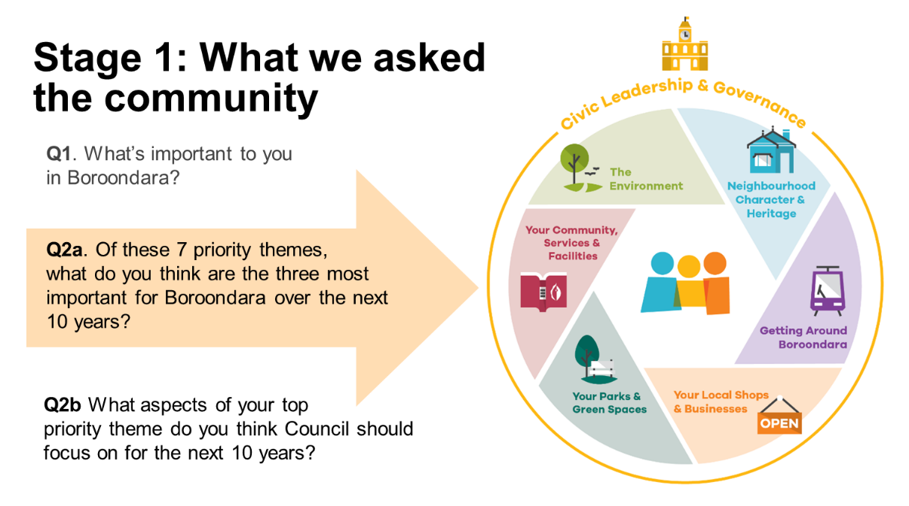
Figure 1: Key questions asked in the Stage 1 community survey,
December 2020 - January 2021

- Stage 2 - prioritisation
In the second stage of consultation, Council hosted 10 workshops, including:
- Boroondara Conversations workshops (total of seven workshops)
- Youth workshop
- Trader workshop
- Health and Wellbeing workshop.

The Boroondara Conversations had the highest number of people of the Stage 2 workshops. In total, 149 residents representing the demographics of our community attended the workshops. The participants developed a deeper understanding of the factors influencing Council’s decision making, before weighing up short and long-term trade-offs and prioritising where they thought Council should focus its resources over the next 10 years. In these sessions, participants also explored the community’s aspirations and deliberated the community vision statement.

The remaining three workshops ensured Council was hearing important insights from younger community members, local traders/business operators and key health and wellbeing agencies and service providers.

- Stage 3 - identification of health and wellbeing priorities
To identify the health priorities of the Plan, data about the health and wellbeing of the Boroondara community was examined, with reference to the Victorian Public Health and Wellbeing Plan 2019-23. Additionally, we heard from 347 community members, via an online survey, who identified their concerns and how they thought Council could best contribute to our community’s health and wellbeing.

Building on our wellbeing commitment developed in 2017, we engaged local health and wellbeing agency partners and stakeholders, and the Boroondara Public Health and Wellbeing Advisory Committee to guide health priority setting.

- Stage 4 - plan development
Through the consultation process, we heard what our community values most about Boroondara, as well as their concerns, hopes and aspirations for the future.
We used this feedback to inform the development of our community’s vision, health priorities and the strategic objectives, strategies, and strategic indicators related to the Plan’s seven themes.
Outlined below is further information about who we heard from.

Who we heard from

Responses were received from the following age groups
123
respondents were aged between 14 and 17.
226
respondents were aged between 18 and 24.
964
respondents were aged between 25 and 39.
2,464
respondents were aged between 40 and 64.
911
respondents were aged between 65 and 79.
158
respondents were aged 80 or over.
Gender
2,905
respondents were females.
1,864
respondents were males.
112
respondents preferred to self-describe or not answer.
Other characteristics
761
respondents were born in a country where English is not a main language.
1,363
respondents were parents of a child/ren younger than 14.
3,957
respondents lived in Boroondara in 2016.
1,368
respondents work or own a business in Boroondara.

People from right across Boroondara responded
290
respondents lived in Ashburton.
359
respondents lived in Balwyn.
466
respondents lived in Balwyn North.
674
respondents lived in Camberwell.

259
respondents lived in Canterbury.

55
respondents lived in Deepdene.
473
respondents lived in Glen Iris.

677
respondents lived in Hawthorn.

393
respondents lived in Hawthorn East.
667
respondents lived in Kew.
172
respondents lived in Kew East.
273
respondents lived in Surrey Hills.
48
respondents lived outside Boroondara

Boroondara Community Plan overview
The 10-year Boroondara Community Plan incorporates the Community Vision, four-year Council plan and four-year Municipal Public Health and Wellbeing Plan. The Plan sets the strategic direction for Council and demonstrates how we will deliver the community’s aspirations while protecting, improving and promoting our community’s health and wellbeing.
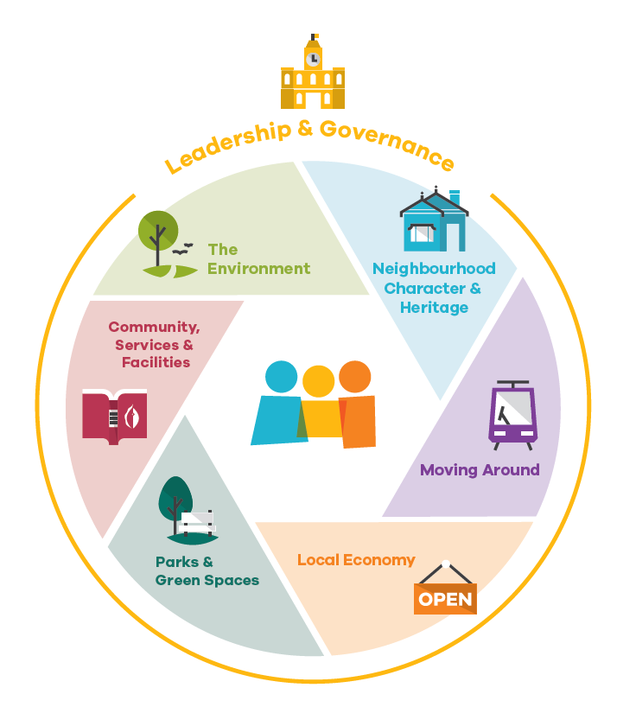
The Plan is structured around seven themes as expressed by the community in 2017. Checking back in with our community in 2020-21, we confirmed these themes still represent what our community want us to focus on over the next 10 years:
- Community, Services and Facilities
- Parks and Green Spaces
- The Environment
- Neighbourhood Character and Heritage
- Moving Around
- Local Economy
- Leadership and Governance
As shown in Figure 2, these seven themes work together with our six health priorities to provide a robust foundation for achieving our community’s vision and our health priorities to create a healthy, inclusive and resilient community.

Figure 2: Boroondara Community Plan seven themes and health priorities
Health priorities:
- Improving mental wellbeing and social connection
- Tackling climate change and its impacts on health
- Preventing all forms of violence
- Reducing harmful alcohol use
- Increasing healthy eating
- Increasing active living

Our wellbeing commitment
Our health and wellbeing is influenced by much more than our individual choices.
Good physical, mental and social health starts in our community, through opportunities to connect, participate and access what we need in order to make healthy choices.
Through the Plan, we are committed to enhancing wellbeing for people who live, work, study or recreate in the municipality as an outcome of everything we do. We will strive to provide a high quality of liveability through our planning, services, places and spaces to enable all members of the community to make healthy choices. We will prioritise action focusing on improving health in order to achieve our community’s vision for Boroondara’s future.
Our commitment to wellbeing is guided by the Victorian Charter of Human Rights and Responsibilities Act 2006, which recognises all people have equal rights to Council services and facilities and the key role the community plays in decision-making. This commitment implies a focus on equity – fair access to resources – so community members of all ages, genders, sexualities, religions, backgrounds, locations and abilities have the same opportunities to achieve good health and wellbeing.
We will work together with our community and local organisations to make good health and wellbeing a reality for all by embedding our health priorities within the seven themes to ensure health and wellbeing is at the centre of everything we do (see Appendix 2).
How to read the Plan
Under each theme, the Plan details what the community told us they value, what Council could do to deliver on these priorities and how we will keep track of our progress and measure our success.
The Plan links what we heard from the community under each theme to Council’s commitments within the Council Plan.
Each theme outlines:
What the community said | What the community said was most important to them.
Strategic objectives | What the community wants to achieve in the next 10 years.
Strategies | What outcomes Council will seek to achieve over the next four years in pursuit of the strategic objective.
Strategic indicators | What measures Council will monitor and collect to demonstrate and report on progress in achieving the strategic objective.
Services | The services Council provides to the community which indicate our priorities to deliver on the strategic objective.

Council’s role
There are four key ways Council can act to implement the Plan, as listed below.
Plan - Council works with the community to ensure community needs are anticipated and met now and in the future.
Deliver - Council directly delivers services, programs or facilities at the local level.
Partner - Council works collaboratively with residents, community groups, the State and Federal Government and other stakeholders to facilitate desired outcomes and build community capacity.
Advocate - Council represents community interests to influence industry, peak bodies and associations, and State and Federal Government decision making.
In the following section, each strategy lists some of the key ways Council can act to implement the Plan.

Theme 1: Community, Services and Facilities
Our community said:
We value safe and clean public places, and facilities and events where people of all ages and backgrounds can interact, learn and be active. We value health and wellbeing services for all community members, especially those in need. These contribute to our sense of connection and the harmony we value across the whole community.
Strategic objective
Community services and facilities are high quality, sustainable, inclusive and strengthen resilience.
Strategies |  |  | Council’s Role
 |  |  | Plan | Deliver | Partner | Advocate
1.1 | Neighbourhoods and community spaces facilitate social connections and belonging by providing, maintaining and activating places for people to meet, organise activities and celebrate events. |  | ✔ | ✔ | ✔ | ✔
1.2 | Health and wellbeing is improved through delivering, facilitating and advocating for services and programs that are accessible and affordable. |  | ✔ | ✔ | ✔ | ✔
1.3 | Arts and culture are showcased by increasing opportunities to participate in artistic and cultural programming. |  | ✔ | ✔ | ✔ | ✔
1.4 | Facilities and sports precincts encourage equal access through social planning, delivery, asset maintenance and renewal activities. |  | ✔ | ✔ | ✔ | ✔
1.5 | Life-long learning is supported by delivering and working with our community and partners to meet the broad range of interests within the community. |  | ✔ | ✔ | ✔ | ✔
1.6 | Residents and visitors feel safe in public spaces through encouraging local activity and creating and maintaining civic areas. |  | ✔ | ✔ | ✔ | ✔
1.7 | Community resilience, safety and public health are improved by working in partnership with community and government organisations. |  | ✔ | ✔ | ✔ | ✔
Strategic indicators

- audience satisfaction with Boroondara Arts curated programs and events
- satisfaction with recreational facilities
- number of community groups using council facilities directly under a lease or license agreement
- food safety assessments (percentage of registered class 1 food premises and class 2 food premises receiving an annual food safety assessment)
- number of people participating in active ageing programs and events
- number of attendances by young people at youth programs or services
- number of vaccinations administered
- number of arts and cultural community events delivered or supported by Council
- overall participation in library services (includes loans, returns, visits programs attendance, e-books and audio loans, enquiries, reservations, Wi-Fi and virtual visits)
- number of community organisations funded through the Community Strengthening Grant Program
- percentage of community strengthening grants provided to culturally and linguistically diverse and disability groups
- percentage of graffiti removed from Council owned assets within one business day of notification.
Services
Service Category |  | Service Description
Arts and Culture |  | - arts and cultural initiatives and programs, such as exhibitions, festivals and events  - program and manage Council's art facilities at the Town Hall Gallery, Kew Court House, Hawthorn Arts Centre and other community spaces  - provide flexible spaces for community and corporate hire, including meetings, community events, private bookings and conference facilities  - oversee the management and care of Town Hall Gallery Collection  - support for community arts and culture groups through funding, partnerships, advice and advocacy.
Asset Management |  | - undertake condition assessments of facilities and infrastructure assets to ensure service standards are maintained  - develop and update long term capital renewal works program for roads, footpaths, drains, bridges, buildings and open space assets  - develop and implement policies, strategies and asset management plans  - develop the asset renewal investment strategy and financial asset forecasts to inform Council's long-term financial strategy  - manage Council's street lighting including repairs, upgrades and provision of new assets  - coordinate the development of Councils overall capital works renewal program and reports on annual progress  - undertake proactive defect inspections of road infrastructure in compliance with Council’s Road Management Plan.
Capital Projects |  | - project management and delivery of the approved capital works for landscape and design, civil and building renewal programs ensuring best value for money  - manage the capital works programs to successfully deliver projects on time and within budget  - encourage and develop innovative design into quality outcomes.
Civic Services |  | - deliver proactive patrol programs to maintain and promote safety and harmony within the community  - deliver administrative and field services in amenity and animal management  - deliver responsible pet ownership initiatives, road safety, amenity regulation and fire prevention  - develop, implement and review appropriate local laws to achieve a safe and liveable environment  - process and issue permits relating to traders, tradespersons, disabled parking, residential parking, animal registrations, excess animals, commercial waste bins, street furniture and other uses of Council controlled land  - register and inspect food and health premises to ensure community safety  - manage permits relating to storm water drainage.
Community Planning and Development |  | - facilitate community connectedness, strengthen community capacity and respond to identified needs through the delivery of a range of programs, partnerships and networking opportunities for Boroondara’s community  - work actively within the community on key community development activities, including major community infrastructure projects and community events  - provide support, advice and assistance to neighbourhood houses and men’s sheds  - develop policies, strategies and plans that address community priorities including the Boroondara Community Plan  - monitor, forecast and analyse community change and wellbeing  - undertake extensive community research on behalf of Council departments and the community  - manage the Boroondara Community Grants Program of annual, small (biannual) commemorative and triennial operational grants  - promote, support and assist the development of volunteering and civic participation through the Boroondara Volunteer Resource Centre  - advocacy and project work to support community safety.
Health and wellbeing |  | - operate the Boroondara Maternal and Child Health support programs and services, Kindergarten Central Enrolment Scheme, Kew Traffic School, and the Boroondara Youth Hub  - undertake strategic planning and policy development to facilitate access to active participation opportunities for the Boroondara community  - facilitate training and support for service providers and voluntary committees of management for early years and youth services and sport and recreation  - provide support and information, services and programs to young people and their families, sport and recreation groups and organisations to enhance health and wellbeing  - facilitate the development of integrated and coordinated services for children, young people and their families, sport and recreation clubs and organisations  - support the inclusion of children into four-year old kindergarten programs through the provision of the Preschool Field Officer Program  - facilitate long day care, occasional care and kindergarten services through the provision of 43 buildings leased to early years management operators and volunteer committees of management  - facilitate participation opportunities by the community in physical activity through the provision of facilities and contract management of the Boroondara Leisure and Aquatic Facilities, the Boroondara Tennis Centre and Junction Skate & BMX Park  - manage leases for 87 facilities to sport and recreation groups, early years management operators and early years committees of management  - work with over 150 sports clubs, across over 30 sports codes at over 100 sports facilities/grounds  - coordinate immunisation services.
Infrastructure maintenance |  | - maintain the City’s infrastructure including buildings, drainage, footpaths and roads, shopping centres, park/street furniture and signs
Liveable Communities |  | - provide home support services under the Commonwealth Home Support Programme including home, personal and respite care, and property maintenance  - provide volunteer and community transport, and social support (including events and planned activity groups)  - coordinate emergency management (recovery) across the municipality  - undertake strategy and development with a focus on positive ageing.
Library Services |  | - provide a large range of relevant, contemporary library collections and services across five libraries and one library lounge, online and via home library services  - provide welcoming community spaces for individual and group study, reflection, activity and discovery  - promote advocate for and support literacy development, reader development, lifelong learning, creative and intellectual development  - provide family, children and adult library programs and activities  - create enthusiasm for local and family history research and discovery, creating connections with our local heritage  - provide opportunities to explore, learn and use new and emerging technology.

Theme 2: Parks & Green Spaces
Our community said:
We are proud and protective of Boroondara’s beautiful parks and open spaces. Seating, playgrounds, toilets, shade and recreation facilities make our open spaces more enjoyable for all residents. We connect with each other in green and open spaces and value the opportunities to exercise, relax and appreciate nature.
Strategic objective
Green and open spaces are provided, well-utilised and enhanced.

Strategies |  |  | Council’s Role
 |  |  | Plan | Deliver | Partner | Advocate
2.1 | Parks and green spaces enable sport and recreation opportunities by maintaining and improving recreation spaces and equipment. |  | ✔ | ✔
2.2 | Our sustainable urban forest is preserved and increased through managing and renewing our open space trees and understory growth. |  |  | ✔ | ✔ | ✔
2.3 | Parks and green spaces are accessible and appealing through maintaining, improving and increasing amenities. |  | ✔ | ✔
2.4 | Green spaces are maintained and increased through management practices and investigating opportunities to acquire or modify existing land. |  | ✔ | ✔ | ✔ | ✔
2.5 | Playgrounds are engaging and safe by improving shading and renewing and diversifying equipment. |  | ✔ | ✔
Strategic indicators

- user satisfaction with a range of parks in Boroondara, benchmarked with participating councils
- satisfaction with appearance public areas
- number of trees on Council managed land
- annual percentage increase of tree cover on Council managed land.
Services
Service Category |  | Service Description
Infrastructure Maintenance |  | - manage and maintain built assets including playgrounds, barbeques, drinking fountains, park furniture, bins, fences and signs.
Landscape and Design |  | - provides landscape design and urban design services to promote use, function and enjoyment of outdoor spaces by the community.
Open Space |  | - manages and maintains Boroondara’s parks, gardens, sportsgrounds and biodiversity sites  - manages and maintains the Freeway Golf Course  - maintains a significant and highly valued urban forest of street and park trees  - strategically plans and develops open space improvements to our parks, gardens, shopping centres and streetscapes  - manage bookings, events and applications associated with Boroondara parks, gardens, reserves, sports grounds and pavilions.

Theme 3: The Environment
Our community said:
We value leadership in environmental sustainability and the adoption of practices to prepare our community for changing climate conditions. We believe in adapting new ways to recycle and manage waste, as part of our commitment to the environment. We value the protection of our natural environment to ensure a healthy and resilient environment for future generations.
Strategic objective
The Environment is considered in all decision making.

Strategies |  |  | Council’s Role
 |  |  | Plan | Deliver | Partner | Advocate
3.1 | Community resilience and capacity to live sustainably is increased through advocacy, education and resources. |  | ✔ |  | ✔ | ✔
3.2 | The environmental impact of Council facilities and assets is further reduced through implementing sustainable practices. |  | ✔ | ✔
3.3 | Municipal and household waste is reduced through initiatives to prevent, reduce, reuse and recycle. |  |  | ✔ | ✔
3.4 | Trees and vegetation on private land are valued through promoting and encouraging our community to retain and enhance greenery. |  |  |  | ✔ | ✔
3.5 | Our leafy streetscapes are maintained and improved through advocating for careful project planning by government regulatory and project authorities, supported by the increased planting of resilient species. |  | ✔ | ✔ |  | ✔
3.6 | Our biodiversity is conserved and maintained through improving the way we manage our diverse plants, animals and natural spaces. |  | ✔ | ✔ | ✔ | ✔
Strategic Indicators

- satisfaction with environmental sustainability
- satisfaction with waste management
- percentage reduction of community emissions compared with 2020 emissions
- percentage reduction of Council CO2 emissions compared with 2007-08 emissions
- volume of harvested water (rain and stormwater) re-used within council buildings and open space irrigation
- kerbside collection waste diverted from landfill (percentage of garbage, recyclables and green organics collected from kerbside bins that is diverted from landfill)
- area of land actively managed for biodiversity.
Services
Service Category |  | Service Description
Environmental Sustainability |  | - help the Boroondara community to live more sustainably in response to emerging environmental challenges (e.g. climate change, water shortage, biodiversity conservation)
 |  | - promote sustainability within built and natural environments in Boroondara
 |  | - develop and implement policies and strategies that set direction in environmental management, public space improvements, conservation of natural resources and sustainable development
 |  | - build the capacity of Council to integrate environmentally sustainable approaches into our buildings and public space improvements, daily operations and decision-making processes.
Open Space |  | - maintain and manage the City’s biodiversity  - maintain and manage all trees on Council managed land including tree planting/establishment, maintenance and renewal programs.
Strategic and Statutory Planning |  | - Administers Council’s Tree Protection Local Law and assesses applications for tree removal.
Waste and Recycling |  | - manages waste services, including kerbside bin-based waste, green, food and recycling collections, bundled green waste, Christmas tree and hard waste collection service  - operates the Boroondara Recycling and Waste Centre  - provide street sweeping services in the municipality and a bulk leaf fall collection program over autumn months.

Theme 4: Neighbourhood Character and Heritage
Our community said:
We value our local heritage. We value Council’s advocacy to protect the distinct character of our neighbourhood streets and carefully regulate new development. Diversity in housing size and affordability is also important to us. We value these things because they contribute to Boroondara’s uniqueness, making it an attractive place to live, work and recreate.
Strategic objective
Protect the heritage and respect the character of Boroondara, while facilitating appropriate, well-designed development.

Strategies |  |  | Council’s Role
 |  |  | Plan | Deliver | Partner | Advocate
4.1 | Boroondara’s heritage places are protected through ongoing implementation of heritage protection controls in the Boroondara Planning Scheme. |  |  | ✔ |  | ✔
4.2 | The history of Boroondara’s heritage places is respected and celebrated through community education. |  |  | ✔ | ✔
4.3 | Development does not adversely impact heritage places through the application of controls and policies set out in the Boroondara Planning Scheme. |  | ✔ |  |  | ✔
4.4 | New development positively contributes to amenity and liveability through design excellence. |  | ✔ |  |  | ✔
4.5 | Better development outcomes are achieved through advocacy to State Government and industry bodies for changes to planning controls and policies. |  |  |  |  | ✔
Strategic indicators
- number of heritage planning scheme amendments considered by Council
- average number of days to process a planning application
- percentage of ‘demolition consents’ under section 29A of the Building Act by Building Services checked within 15 business days
- percentage of Council planning decisions upheld and decisions successfully mediated at VCAT.
Services
Service Category |  | Service Description
Asset Protection |  | - protect public assets under the control of Council to minimise the impact of works by others on the community.
Building Services |  | - encourage desirable building design outcomes for amenity protection and to maintain consistent streetscapes through the Report and Consent process
 |  | - assess building permit applications, conduct mandatory inspections and issue occupancy permits/final certificates for buildings and structures
 |  | - provide property hazard and building permit history information to designers, solicitors, private building surveyors and ratepayers
 |  | - conduct fire safety inspections and audits on public and/or high risk buildings to ensure life safety of occupants and the public
 |  | - maintain a register of swimming pools and spas located within the municipality, conduct safety barrier compliance inspections when required to ensure a safer built environment
 |  | - administer and enforce the Building Act 1993 and Building Regulations including investigation of illegal and dangerous buildings to ensure public and occupant safety
 |  | - provide building regulatory and technical advice to residents and ratepayers in relation to local planning policy
 |  | - assess section 29A demolition requests in accordance with the Building Act 1993.
Strategic and Statutory Planning |  | - process and assess planning applications in accordance with the Planning and Environment Act 1987, the Boroondara Planning Scheme and Council policies  - provide advice about development and land use proposals as well as providing information to assist the community in its understanding of these proposals  - investigate non-compliances with planning permits and the Boroondara Planning Scheme and take appropriate enforcement action when necessary  - assesses applications to subdivide land or buildings under the Subdivision Act 1988  - defend Council planning decisions at the Victorian Civil and Administrative Tribunal  - advocate for and prepare land use policy and standards within the context of Victorian State policy  - promote sustainable design and development and heritage conservation  - manage the Municipal Strategic Statement  - develop policies and plans to guide land use and development.  - assess traffic, parking and drainage implications of planning permit applications.

Theme 5: Moving Around
Our community said:
We value access to private, public and active transport options to move around Boroondara. We value measures to alleviate traffic congestion and having safe and interconnected cycling and walking options, including well-maintained footpaths for pedestrians. We value these because the convenience, time savings and reduced environmental impact associated with excellent transport can enhance quality of life at all life-stages.
Strategic objective
Travel options are safe, efficient and accessible, with active and public transport encouraged.

Strategies |  |  | Council’s Role
 |  |  | Plan | Deliver | Partner | Advocate
5.1 | Safe roads are provided through proactive maintenance, renewal and community education. |  | ✔ | ✔ | ✔ | ✔
5.2 | Traffic congestion is better managed through advocacy to State and Federal governments for changes to main roads |  |  |  |  | ✔
5.3 | Shared paths and footpaths are fit-for-purpose through continued improvements to surface condition and lighting. |  | ✔ | ✔ |  | ✔
5.4 | Off-road bike paths and on-road cycling lanes are interconnected and safe through expanding access and infrastructure for cyclists. |  | ✔ | ✔ |  | ✔
5.5 | Sustainable transport use is encouraged and supported through delivery of green travel programs and advocacy to State and Federal Governments. |  | ✔ | ✔ | ✔ | ✔
5.6 | Emerging transport options including e-mobility are planned for by exploring initiatives that increase safety and public confidence in e-mobility use and infrastructure. |  | ✔ |  |  | ✔
Strategic indicators

- satisfaction with sealed local roads
- satisfaction with local shared paths for cycling and walking as a way to get around Boroondara
- percentage of sealed local roads that are below the renewal intervention level set in the Road Management Plan
- percentage of footpath inspections completed and defects remediated within the timeframes as specified in the Road Management Plan.
- number of sustainable transport programs delivered to primary schools
- number of traffic counts and surveys used to investigate, assess and respond to traffic and parking issues.
- number of advocacy initiatives related to public transport services
- average daily bicycle users for Gardiners Creek Trail, the Anniversary Trail, Koonung Trail and Main Yarra Trail
- length of converted shared paths or new facilities to provide separate paths for pedestrians and bicycle riders.
Services
Service Category |  | Service Description
Civic Services |  | - deliver the School Crossing Supervisor program through the provision of supervision at school crossings and the overall management and administration of the program  - deliver administrative and field services in parking management  - assess full and part road closure applications relating to works.
Road Maintenance and Repair |  | - road maintenance to meet road management plan requirements  - undertake road repairs and associated line marking  - road reinstatements that require works following developments.
Traffic and Transport |  | - develop, assess and implement engineering solutions which address the amenity of residential and commercial areas  - implement parking and traffic management strategies  - assess street party applications  - investigate black spot accident locations and develop remedial treatments  - coordinate and implement sustainable transport initiatives including car share, green travel plans, school travel plans and a variety of active transport programs  - design, consult and implement transport projects including on road bicycle lanes, shared paths, road safety initiatives, pedestrian and bicycle improvements, disability access and traffic treatments  - advocate for improvements to public transport and sustainable transport initiatives  - develop feasibility studies and grant applications to State and Federal authorities for accident black spot locations and pedestrian and bicycle improvement projects  - provide strategic transport planning advice and develop associated studies  - assess high and heavy vehicle route applications  - provide input into major State government transport projects.

Theme 6: Local Economy
Our community said:
We value our shopping strips, including places where we can shop, socialise and dine out close to home. We strive to support locally owned businesses and want to attract more diverse businesses to our neighbourhoods to enable us to live locally and contribute to a thriving local economy.
Strategic objective
Support local businesses and enhance shopping precincts, fostering a strong economy and welcoming places for the community.

Strategies |  |  | Council’s Role
 |  |  | Plan | Deliver | Partner | Advocate
6.1 | Local retail precincts provide a gathering point for residents and attract shoppers through supporting initiatives which encourage a range of businesses needed by the community. |  | ✔ | ✔ | ✔ | ✔
6.2 | Local traders and businesses are supported by providing training and upskilling initiatives to maintain and increase viable businesses. |  |  | ✔ | ✔ | ✔
6.3 | Shopping centres and strips are hubs of community activity through activating local shopping precincts. |  | ✔ | ✔ | ✔ | ✔
6.4 | Shopping centres are clean, well-maintained and inviting, through revitalising infrastructure and streetscapes and proactive renewal and maintenance. |  |  | ✔
6.5 | Local visitation is increased through showcasing and promoting local shopping and attractions. |  | ✔ |  | ✔ | ✔
Strategic indicators

- participant satisfaction in Council’s business training activities
- satisfaction with work to improve quality of streetscapes in shopping precincts to attract and retain good shops and businesses
- number of permits for outdoor trading
- number of proactive strip shopping centre maintenance inspections completed.
Services
Service Category |  | Service Description
Local Economies |  | - manage the implementation of the Economic Development and Tourism Strategy for Council  - strengthen the viability of local businesses, including strip shopping centres, and facilitate eight special rates scheme for shopping centres  - facilitate the Boroondara Business Network to support new and established businesses, through training and mentor services  - facilitate the Boroondara Farmers Market, the Hawthorn Makers Market, the Camberwell Fresh Food Market and the Camberwell Sunday Market  - facilitate the Vibrant Retail Precincts stream of Council’s community grants program  - facilitate regular networking opportunities for the local business community  - support and promote tourism opportunities across the municipality  - deliver the City-wide Christmas in Boroondara Program  - facilitate a placemaking approach in our public spaces and shopping centres to increase social interactions, economic viability and enhance the health and wellbeing of our community.
Minor Shopping Centre Upgrade and Maintenance |  | - implement the Shopping Centre Improvement Program, which delivers streetscape improvements to our small and medium sized shopping centres
 |  | - undertake proactive maintenance inspections by the shopping centre service crew and carry out maintenance and upkeep of these precincts.

Theme 7: Leadership and Governance
Our community said:
We value strong, respectful Council leaders who govern responsibly by ensuring decisions are transparent and resources are carefully allocated. We expect to be consulted and learn about services and facilities provided by Council through a variety of communications channels so all members of our community, including hardly reached groups, are empowered to have their say and make the most of what Council offers. Where issues are outside Council’s direct control, we value Council advocating on the priorities important to our community and keeping us informed.
Strategic objective
Ensure decisions are financially and socially responsible through transparent and ethical processes.

Strategies |  |  | Council’s Role
 |  |  | Plan | Deliver | Partner | Advocate
7.1 | Decision-making is transparent and accountable through open governance processes with timely communication and reporting. |  |  | ✔
7.2 | Resources are responsibly allocated and used through sound financial and asset planning, procurement and risk management practices. |  | ✔ | ✔
7.3 | Deliver the Boroondara Community Plan through partnerships with our community and a high performing focused organisation. |  | ✔ | ✔ | ✔ | ✔
7.4 | The voices of our community are heard through engagement strategies to allow effective representation on current and long-term community needs. |  | ✔ | ✔ | ✔
7.5 | The community’s interests are represented by Council, through leadership and strong advocacy to external stakeholders. |  | ✔ |  | ✔ | ✔
7.6 | Convenient and accessible choices for interacting with Council are provided, by offering various options for services and engagement. |  | ✔ | ✔
7.7 | Services are enhanced through improvements to Council’s technology, data, processes and performance. |  | ✔ | ✔
7.8 | Celebrate and recognise Aboriginal and Torres Strait Islander culture, knowledge and heritage through implementing initiatives in partnership with our community and stakeholders. |  | ✔ | ✔ | ✔ | ✔
Strategic indicators

- satisfaction with making community decisions
- satisfaction with informing the community
- satisfaction with the overall performance of Council
- satisfaction with community consultation and engagement
- satisfaction with customer service
- percentage of freedom of information requests responded to within prescribed timeframes
- current assets compared to current liabilities
- percentage of adopted capital projects completed at the conclusion of the financial year (based on most recent amended budget)
- number of transactions initiated via our website
- number of calls abandoned when customers are trying to reach Council's customer service
- number of cyber security incidents that compromise user data
- access to Council’s website (percentage of time available).
Services
Service Category |  | Service Description
Chief Financial Office |  | - produce the Budget (plus three subsequent financial years) and Financial Plan (10 years) and manage Council’s budgeting/forecasting and financial reporting systems  - manage procurement and conduct of all public tenders  - manage rates and property services, including Council databases and communication of the rate payment options available to residents  - handle the administration and leasing of Council's property holdings including the Camberwell Fresh Food Market  - manage all acquisitions and disposals of land for Council.
Council Operations |  | - operation of Camberwell and Hawthorn office locations, including maintenance, security and servicing of essential services such as lifts, extinguishers, exit signs, etc.
Customer Support and Corporate Information |  | - coordinate improvement to service delivery to the community and within Council through the use of technology and process change  - manage customer engagement, including enquiries and complaints  - provide a centralised approach to the first-contact customer interaction and a tiered support model for customer enquiries including case management.
Digital |  | - develop new public facing digital services and information based on customer requirements, evidence based research, best practice user experience and human centered service design principles and practices.
Governance and Legal |  | - manage Freedom of Information, Information Privacy and Data Protection, public interest disclosures and internal ombudsman functions  - maintain statutory registers, authorisations and delegations  - administer the conduct of Council elections  - coordinate civic events, citizenship ceremonies and Citizens of the Year Awards  - coordinate enterprise business risk for the organisation including Council’s Crisis Management Plan and department Business Continuity Plans  - manage public liability, professional indemnity, motor vehicle and property claims  - monitor and report on legislative changes and impacts for Council operations.
Information Technology |  | - through strong Information Technology governance practices, ensure cost and value for money principles underpin all investment decisions  - oversee and manage information security related risks to ensure sensitive customer and Council data remains secure and available only to those it is intended for  - lead and support the implementation of technology related initiatives which enable the required customer and organisational outcomes to be achieved.
People, Culture and Development |  | - deliver the functions of health, safety and wellbeing, human resources, payroll and organisational development  - coordinate recruitment, employee relations, remuneration, award/agreement interpretation and work-force planning.
Strategic Communications |  | - manage the Boroondara brand and corporate communications channels and content  - deliver advocacy campaigns in collaboration with the responsible Director, CEO and Councillors  - provide a broad range of engagement tools to facilitate the capture of external feedback.
Strategy and Performance |  | - develop and deliver the annual planning cycle for the Council Plan and Budget  - manage Council's reporting system and conduct performance reporting for the Quarterly Performance Report and the Annual Report  - provide external grant application support for significant project funding opportunities  - develop high quality partnerships with public and private sector organisations.

Our health priorities
Overall, the Boroondara community reports good health and quality of life, and this is further evidenced by data relating to a large range of personal, social, economic, and environmental factors which influence health status.
However, the data does reveal some areas of concern which require additional attention over the next four years. Outlined below are the six health priorities for Council to focus on which emerged through research and consultation undertaken to inform the development of the Municipal Public Health and Wellbeing Plan 2021-25. These are informed by the Victorian Public Health and Wellbeing Plan 2019-2023 health priorities and represent the most significant preventable causes of poor health and wellbeing in Boroondara, as well as those areas where our organisation and our partners can make changes to positively influence the health outcomes of our community.
 | Health priority outcomes and why they matter
Improving mental wellbeing and social connection | People feel connected to others, have a sense of belonging, can cope with the usual stresses of life, and have opportunities and capacity to contribute to community life.  Mental health is an essential ingredient of individual and community wellbeing and significantly contributes to the social, cultural and economic life of our City. The benefits of preventing mental ill health and supporting social connection at all life stages are not just for the individual, but for the whole community.
Tackling climate change and its impact on health | Communities are resilient and safe through adapting to and preventing the health impacts of climate change.  Climate change affects our health and wellbeing in a variety of ways, including through the impacts of extreme events, worsening air quality and effects on our mental health. Actions to mitigate and adapt to climate change can have direct and indirect health co-benefits, from promoting active modes of travel which also reduce air pollution, to increasing our tree canopy and reducing the urban heat island effect. Efforts to tackle climate change, through sustainable living practices, represent one of the greatest opportunities to improve health this century.
Preventing all forms of violence | People feel safe, respected and live their lives free from violence.  We all have a right to feel safe and respected, and to live our lives free from violence. Family violence has a profound impact on health and wellbeing with far-reaching impacts including deteriorated physical and mental health, loss of housing, loss or limited access to employment, precarious financial security, isolation and alienation of extended family/social support and, in extreme cases, death.
Reducing harmful alcohol use | People are supported and encouraged to make healthy choices to reduce harmful alcohol use.  Alcohol-related harm is a significant preventable health issue. Drinking too much can lead to harmful short-term and long-term effects. It can have negative impacts on a person’s mental and physical health and their families and the broader community.
Increasing healthy eating | Nutritious food is accessible to all with healthy choices supported and encouraged.  Reduced fruit and vegetable intake is linked to a range of poor health outcomes and increased risk of non-communicable diseases. There are also significant co-benefits of increasing healthy eating, from improving mental and physical health to helping mitigate climate change.
Increasing active living | Physical activity is encouraged, supported and easily incorporated into daily life.  Incorporating physical activity into each day is associated with and can prevent many non-communicable diseases such as heart disease, some cancers, diabetes, musculoskeletal conditions and depression. Increased physical activity is also a health co-benefit of taking action on climate change through reduced car dependency by engaging in active travel.

Addressing health and wellbeing inequities
While a life-stage approach will be adopted to address the health priorities, it is also necessary to focus actions on the health inequities which are apparent in the wellbeing outcomes for particular population groups. Research conducted on disadvantage has identified these groups as including, but not limited to: older people living alone, sole-parent families, Aboriginal and Torres Strait Islander peoples, people with a disability, carers, young people who are disengaged from the workforce and learning, LGBTQIA+ community members, people with limited proficiency in English, people who are homeless and social housing tenants. This approach is supported by our wellbeing commitment set out in this Plan.

Each year, an annual action plan will outline how these health priorities will be implemented. Annual action plans and evaluation reports will be available online at https://www.boroondara.vic.gov.au/about-council/council-administration/policies-plans-and-strategies/reports/boroondara-community-plan/our-health-priorities.
Health indicators will be regularly updated and available at https://www.boroondara.vic.gov.au/about-council/history-and-demographics/health-statistics/health-priorities-statistics.

Implementing the Plan
Our integrated planning and reporting framework
As shown in Figure 3, the Plan directly informs Council’s suite of strategic documents within our integrated planning and reporting framework.
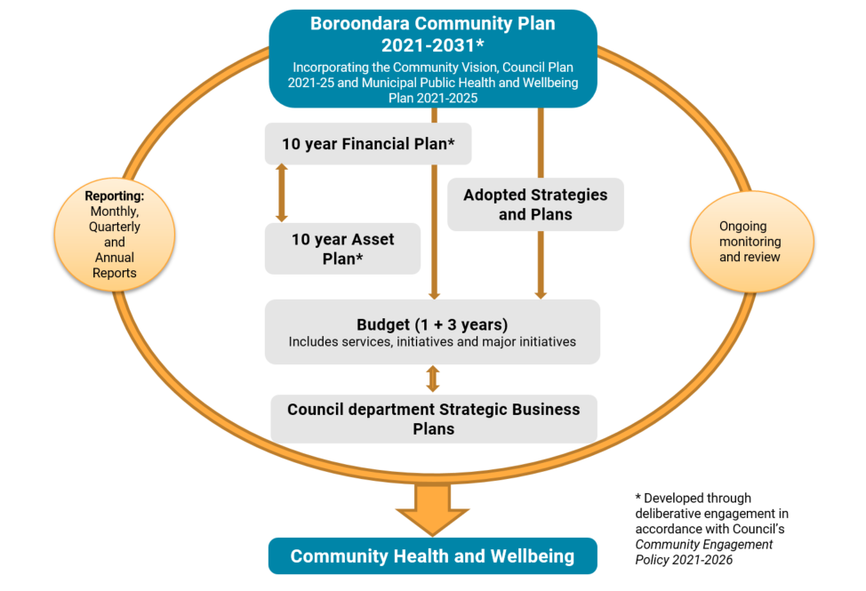
Figure 3: Council’s integrated planning and reporting framework
Our integrated planning and reporting framework includes our:
- ten year Financial Plan and 10 year Asset Plan, which detail our strategic planning and decision-making process for Council’s future financial and asset resource allocation, mapped to the seven themes of the Plan
- adopted strategies, plans and policies which detail our medium term goals for specific service areas and how these goals will be delivered and measured. Future strategies, plans and policies will demonstrate a link to at least one of the Plan’s themes. A list of publicly available policies, plans and strategies is available online at https://www.boroondara.vic.gov.au/about-council/council-administration/policies-plans-and-strategies
- annual budget (1 + 3 years) informed by our annual department Strategic Business Plans, which details the allocation of resources, services, initiatives, and associated performance indicators, mapped to the seven themes of the Plan.
- monthly, quarterly and annual reporting to show progress on the delivery of these strategic documents, mapped to the seven themes of the Plan.
Each of these documents, where possible, aligns to the seven themes of the Plan, creating consistency and complete integration of the community’s aspirations and priorities across our planning, budgeting, asset management and reporting.
This integrated planning and reporting approach provides a line of sight through every department in Council to achieve and report back on our community’s vision and our wellbeing commitment. It enables our organisation, our community and our partners to adapt and prioritise strategies and actions, which are responsive to community needs and legislative changes, as they emerge and change over time.

Evaluating, refreshing and reporting on the Plan
In demonstrating our commitment to delivering on the Plan, our integrated planning and reporting framework involves comprehensive monitoring, reporting and evaluation of Council’s performance.
This includes monitoring and reporting against the annual initiatives and strategic indicators to demonstrate progress against the Plan. The strategic indicators include outcome indicators, which assess the overall impact and achievement of the strategic objectives, and output indicators, which measure specific activities.
To ensure accountability and transparency, we will publish Council’s financial and non-financial progress against the annual initiatives, strategic indicators, and other key performance indicators set by departments or required by legislation, including the Local Government Performance Reporting Framework (LGPRF) in the Quarterly Performance Reports (QPR) and Annual Report.
Health and liveability indicators will be monitored to track our community’s health and wellbeing using local, regional and State level data in line with the Victorian Public Health Outcomes Framework. While Council has a limited service delivery role as it relates to health services, Council actively seeks to advocate to health agencies, State and the Federal Government regarding needed health and wellbeing services to meet the needs of the community. This data will be reported against annual health priority action plans, which can be found at https://www.boroondara.vic.gov.au/about-council/council-administration/policies-plans-and-strategies/reports/boroondara-community-plan/our-health-priorities.
The Plan sets a 10 year outlook and we will check in with the community at the end of each Council term (four years) to ensure alignment with new trends, demands and changes to government and community priorities. Council will use a deliberative engagement process to ensure we continue to reflect the aspirations and priorities of our community in all that we do.

Partnerships
Delivering the Plan together
Delivery of the Plan will require collaborative partnerships between Council and a range of stakeholders including community members and groups, service providers, local industries, peak bodies and associations, and State and Federal Government.
To support this approach, our partners will be able to work with us in a number of ways including partnering on regional working groups, and providing feedback and submissions on specific projects through public exhibition and consultation. Working together will ensure both Council and our partners have access to the best available information, and can coordinate our efforts to achieve the greatest impact.
In addition to these partnership opportunities, we will continue to convene the Boroondara Public Health and Wellbeing Advisory Committee, which will provide advice on the implementation of our Municipal Public Health and Wellbeing Plan. This will provide the opportunity for key stakeholders to identify areas for joint action and to provide advice about the implementation of community health and wellbeing actions. Key members of the advisory committee will be our health promotion funded organisations: Department of Families, Fairness and Housing, Department of Health, Access Health and Community, Inner East Primary Care Partnership, Women’s Health East and Eastern Melbourne Primary Health Network.

Keeping in touch with the community
Our community plays a key role in the implementation of the Plan and will be able to have their say on the implementation of the Plan. Community participation is encouraged through a range of forums including advisory committees, and by participating in consultation activities on draft Council policies and strategies, some of which include infrastructure renewals, placemaking visions and plans, and structure plans.
We will provide opportunities for the community to provide feedback on our progress as we implement the Plan and to participate in consultation at the beginning of each Council term to ensure the Plan remains relevant.
We look forward to your continued involvement with the Boroondara Community Plan.

Councillors and wards
Each of the City of Boroondara’s councillors represent one of our 11 Council wards. Our councillors have each been elected by members of the community for a four year term of office.

Solway Ward Council
Cr Garry Thompson
Phone: 9278 4457
Mobile: 0417 153 512
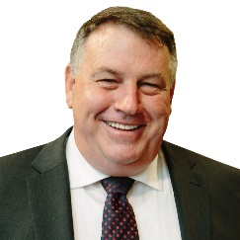
Email: garry.thompson@boroondara.vic.gov.au
Bellevue Ward Councillor
Cr Jim Parke
Phone: 9835 7840
Email: jim.parke@boroondara.vic.gov.au
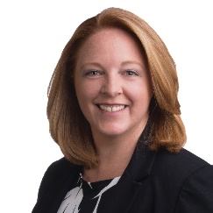
Cotham Ward Councillor
Cr Felicity Sinfield
Phone: 9835 7841
Mobile: 0418 793 573
Email: felicity.sinfield@boroondara.vic.gov.au
Gardiner Ward Councillor
Cr Victor Franco
Phone: 9835 7842
Mobile: 0482 888 635
Email: victor.franco@boroondara.vic.gov.au
Glenferrie Ward Councillor
Cr Wes Gault
Phone: 9835 7849
Mobile: 0482 999 939
Email: wes.gault@boroondara.vic.gov.au
Junction Ward Councillor
Cr Di Gillies
Phone: 9835 7843
Mobile: 0482 999 919
Email: di.gillies@boroondara.vic.gov.au

Lynden Ward Councillor
Cr Lisa Hollingsworth
Phone: 9835 7844
Mobile: 0417 908 485
Email: lisa.hollingsworth@boroondara.vic.gov.au
Maling Ward Councillor
Cr Jane Addis
Phone: 9835 7845
Mobile: 0409 267 902
Email: jane.addis@boroondara.vic.gov.au
Maranoa Ward Councillor
Cr Cynthia Watson
Phone: 9835 7846
Mobile: 0419 488 204
Email: cynthia.watson@boroondara.vic.gov.au
Riversdale Ward Councillor
Cr Susan Biggar
Phone: 9835 7810
Mobile: 0482 999 959
Email: susan.biggar@boroondara.vic.gov.au
Studley Ward Councillor
Cr Nick Stavrou
Phone: 9835 7848
Mobile: 0482 999 209
Email: nick.stavrou@boroondara.vic.gov.au

Appendix 1 - Responsibilities under the Public Health and Wellbeing Act
The Public Health and Wellbeing Act 2008 states a Municipal Public Health and Wellbeing Plan (MPHWP) must have regard to the Victorian Public Health and Wellbeing Plan 2019-23, and specify measures to prevent family violence and respond to the needs of victims of family violence in the local community. The Climate Change Act 2017 also states Council must have regard to the potential impacts of climate change when preparing a MPHWP.
Through the implementation of the Boroondara Community Plan 2021-31, we will have regard to the strategic directions set out in the Victorian Public Health and Wellbeing Plan 2019-2023 and will adopt the following components to address health and wellbeing:
- improvements at every stage of life
- place-based approaches
- promoting health and wellbeing outcomes and reducing inequalities, in particular through improving mental wellbeing, tackling climate change and its health impacts, preventing all forms of violence, reducing harmful alcohol use, promoting healthier eating and active living.
Council will also have regard to our responsibility in relation to climate change, to provide leadership and good governance, as set out in the section 17 of the Victorian Climate Change Act 2017. We will do this through the implementation of a large number of strategies which can be broadly captured by the following directions:
- protecting and preserving our trees, nature and open space
- showing leadership in reducing the environmental impact of our facilities and services
- supporting our community to reduce their environmental impact through reduced waste generation and diverting waste from landfill.
Council will also have regard to the recommendations of the Royal Commission into Family Violence by working with our community and partners to address and prevent family violence by:
- designing and supporting safe facilities and public environments for all
- promoting and supporting the participation of girls and women in all areas of community life, Council services and facilities through respectful and inclusive practices to improve equity
- creating strong neighbourhoods that promote respectful and supportive social connection
- ensuring Council services are equipped to respond, where appropriate, to all forms of family violence
- working with partners to address family violence and initiatives, which can contribute to a community that values equality and respect
- undertaking our requirements as per the Gender Equality Act 2020 and in particular, the requirement to do gender impact assessments of all new policies, programs and services that directly and significantly impact the public, as well as those up for review.

Appendix 2 - Municipal Health and Wellbeing Plan summary
Strategies under all seven BCP themes will contribute to creating the conditions for community health and wellbeing. The below table highlights key strategies, which will directly contribute to each of the six health priorities.
BCP Theme | Key BCP strategy | Improving mental wellbeing and social connection | Tackling climate change and its impacts on health | Preventing all forms of violence | Reducing harmful alcohol use | Increasing healthy eating | Increasing active living
Theme 1: Community, Services & Facilities | - Neighbourhoods and community spaces facilitate social connections and belonging by providing, maintaining and activating places for people to meet, organise activities and celebrate events. | ✔ | ✔ | ✔ | ✔ | ✔ | ✔
 | - Health and wellbeing is improved through delivering, facilitating and advocating for services and programs that are accessible and affordable. | ✔ | ✔ | ✔ | ✔ | ✔ | ✔
 | - Arts and culture are showcased by increasing opportunities to participate in artistic and cultural programming. | ✔
 | - Facilities and sports precincts encourage equal access through social planning, delivery, asset maintenance and renewal activities. | ✔ |  | ✔ | ✔ |  | ✔
 | - Life-long learning is supported by delivering and working with our community and partners to meet the broad range of interests within the community. | ✔ | ✔ |  |  | ✔
 | - Residents and visitors feel safe in public spaces through encouraging local activity and creating and maintaining civic areas. | ✔ |  | ✔ |  |  | ✔
 | - Community resilience, safety and public health are improved by working in partnership with community and government organisations. | ✔ |  | ✔ | ✔
Theme 2: Parks & Gardens | - Parks and green spaces enable sport and recreation opportunities by maintaining and improving recreation spaces and equipment. | ✔ |  |  |  |  | ✔
 | - Our sustainable urban forest is preserved and increased through managing and renewing our open space trees and understory growth. |  | ✔
 | - Parks and green spaces are accessible and appealing through maintaining, improving and increasing amenities. | ✔ |  |  |  |  | ✔
 | - Green spaces are maintained and increased through management practices and investigating opportunities to acquire or modify existing land. |  | ✔ |  |  | ✔ | ✔
 | - Playgrounds are engaging and safe by improving shading and renewing and diversifying equipment. | ✔ |  |  |  |  | ✔
BCP Theme | Key BCP strategy | Improving mental wellbeing and social connection | Tackling climate change and its impacts on health | Preventing all forms of violence | Reducing harmful alcohol use | Increasing healthy eating | Increasing active living
Theme 3: The Environment | - Community resilience and capacity to live sustainably is increased through advocacy, education and resources. | ✔ | ✔ |  |  | ✔
 | - The environmental impact of Council facilities and assets is further reduced through implementing sustainable practices. |  | ✔
 | - Municipal and household waste is reduced through initiatives to prevent, reduce, reuse and recycle. |  | ✔
 | - Trees and vegetation on private land are valued through promoting and encouraging our community to retain and enhance greenery. |  | ✔
 | - Our leafy streetscapes are maintained and improved through advocating for careful project planning by government and project authorities, supported by the increased planting of resilient species. |  | ✔
 | - Our biodiversity is conserved and maintained through improving the way we manage our diverse plants, animals and natural spaces. |  | ✔
Theme 4: Neighbourhood Character & Heritage | - The history of Boroondara’s heritage places is respected and celebrated through community education. | ✔ |  |  |  |  | ✔
 | - New development positively contributes to amenity and liveability through design excellence. | ✔ |  |  |  |  | ✔
Theme 5: Moving Around | - Safe roads and footpaths are provided through proactive maintenance, renewal and community education. |  |  |  |  |  | ✔
 | - Shared paths and footpaths are fit-for-purpose through continued improvements to surface condition and lighting. |  |  | ✔ |  |  | ✔
 | - Off-road bike paths and on-road cycling lanes are interconnected and safe through expanding access and infrastructure for cyclists. |  | ✔ |  |  |  | ✔
 | - Sustainable transport use is encouraged and supported through delivery of green travel programs and advocacy to State and Federal Governments. |  | ✔
 | - Emerging transport options including e-mobility are planned for by exploring initiatives that increase safety and public confidence in e-mobility use and infrastructure. |  | ✔
Theme 6: Local Economy | - Shopping centres and strips are hubs of community activity through activating local shopping precincts. | ✔
 | - Local visitation is increased through showcasing and promoting local shopping and attractions. | ✔ |  |  |  |  | ✔
BCP Theme | Key BCP strategy | Improving mental wellbeing and social connection | Tackling climate change and its impacts on health | Preventing all forms of violence | Reducing harmful alcohol use | Increasing healthy eating | Increasing active living
Theme 7: Leadership & Governance | 7.2 Resources are responsibly allocated and used through sound financial and asset planning, procurement and risk management practices. |  |  |  |  | ✔
 | - The voices of our community are heard through engagement strategies to allow effective representation on current and long-term community needs. | ✔
 | - Celebrate and recognise Aboriginal and Torres Strait Islander culture, knowledge and heritage through implementing initiatives in partnership with our community and stakeholders. | ✔

Demographic information is from the Census of Population and Housing, 2016 unless otherwise specified.
ABS, Estimated Resident Population, 2020.
Id Consulting, 2020, City of Boroondara population forecast.
Department of Social Services - JobSeeker and Youth Allowance recipients, 2021.
ABS, Counts of Australian Businesses, including Entries and Exits, 2016 to 2020.
City of Boroondara, Economic Development & Tourism Strategy 2016 - 2021.
Victorian Population Health Survey, 2017 unless otherwise specified.
Public Health Information Development Unit, 2020, Social Health Atlas of Australia - Data by LGA.
Public Health Information Development Unit, 2020, Social Health Atlas of Australia - Data by LGA.
Statistical Data for Victorian Communities, 2016, Indicators of health, housing, community, education, employment, transport and safety in metropolitan municipalities, Victoria.
ABS, 2016, Census of Population and Housing.
Greenspace Consultant, 2017, Boroondara Canopy Cover Assessment 2006 to 2016.
CSIRO, 2019, Climate Change in Australia.
VicHealth Indicators Survey, 2015.
Crime Statistic Agency, 2021.
Total figure is 4,881 and includes responses to Stage 1 community survey and Stage 2 Boroondara Conversations and youth workshops. Not all figures add up to 4,881 as not all participants provided age or suburb data. Community health and wellbeing survey, Trader and Health and Wellbeing workshops participation is not included in total numbers presented. Targeted surveying methods were used to ensure the sample of respondents was as representative as possible of the broader Boroondara community on key demographic factors.
Theme names have been changed in response to community sentiment and are presented in no particular order.

