Victoria Park South Oval Extension
Project overview
City of Boroondara received a proposal from the Kew Football Club to extend the Victoria Park South Oval.
By extending the ground, the club will be able to schedule women’s matches to support female participation. Currently the ground is too small to consistently host female senior matches.
What are we doing?
The oval extension proposed scope of works includes:
- The relocation of one sports ground lighting pole (aerial below)
- Two small trees will be removed and are proposed to be replaced
- The inclusion of a 1m high retaining wall approximately 160m in length from the existing bluestone retaining wall
- Replacement of player benches and perimeter fencing in the oval extension area
- Proposed improvements to the existing bluestone retaining wall.

Project funding and time frames
Pending community consultation, the oval extension project will be fully funded through the Australian Government Grant received by the Kew Football Club. Council is supporting the project by consulting with the community and overseeing the works. These works are proposed to commence late 2021 and be completed by April 2022.
Will there be any changes to the reserve usage?
The ground extension will result in the ability to consistently program women’s matches on this ground. The extension will also enable U19 (male and female) teams to play on this ground.
Currently the South Oval is allocated to Kew Football Club on a Saturday afternoon, however the ground is used on an ad hoc basis for women’s matches due to its current size. The ground extension will enable women’s matches to be played approximately nine Saturday’s a year during winter. It will mean both the north and south ovals operating on these days, as they currently do on most Sundays throughout winter.

What are the implications for the community while works are being carried out?
Whilst works are taking place, the immediate areas will be made safe to ensure the safety of all park users. The community and sporting clubs will still be able to access and use the oval during this time.
Council will endeavour to cause minimal disruption to residents and park users during this time.
An aerial of expected ground extension below:

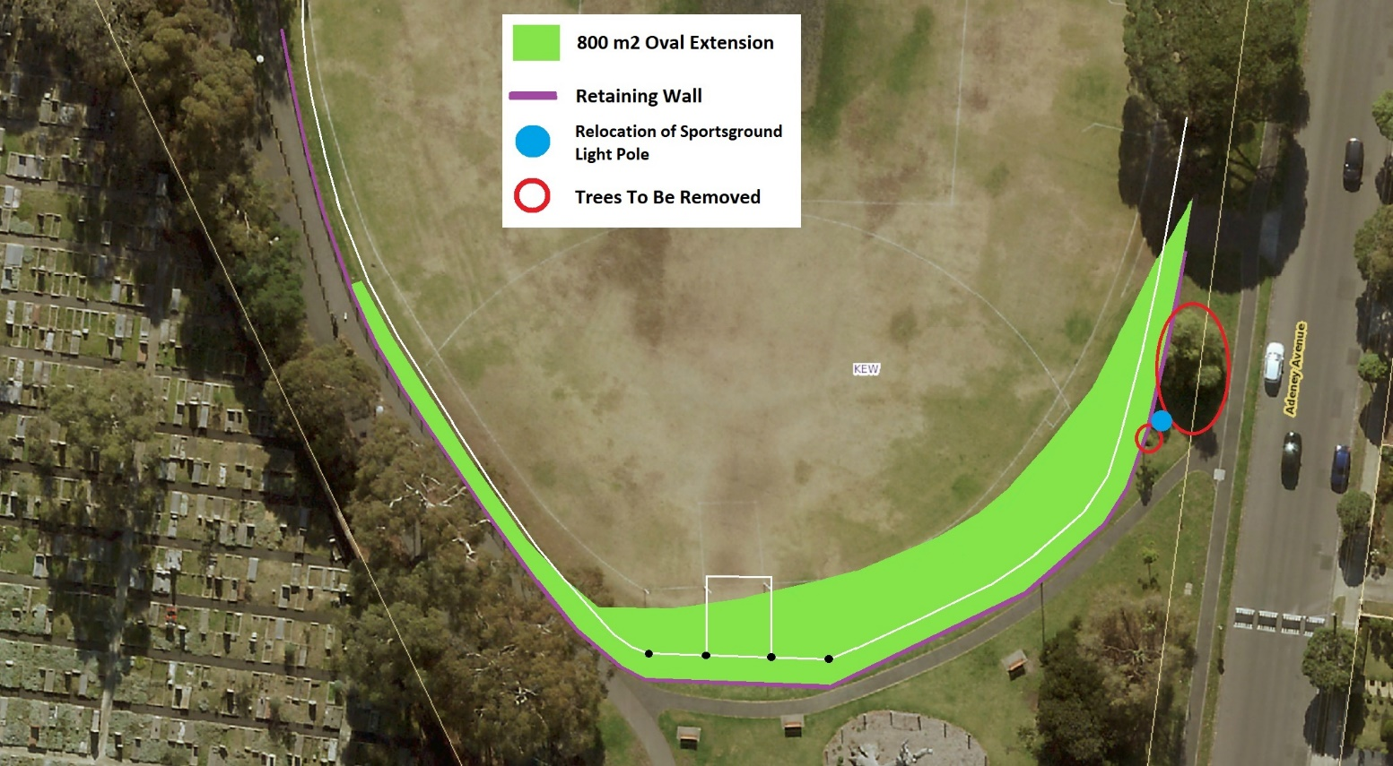
Victoria Park South Cricket Net Renewal
The project
It is important Council provides facilities that are fit for purpose, safe to use for participants, spectators and the broader community, as well as contributing to good health and a sense of community connection.
The current cricket nets at Victoria Park South are reaching the end of their useful life and require renewal. The renewal of the cricket nets will support the training needs of the Kew Cricket Club and will be available for community use.
The project will consist of the upgrade of the current practice net facility and provide a modern, functional and safe training space that meets Cricket Australia's Community Cricket Facility Guidelines. The scope of works includes the replacement of the current structure with the
following components:
• 2 practice bays 3.6m in width and 30m in length (including run-up)
• 14m of black chain mesh fence 3.6m in height on either side of the structure and between bays
• A pitched roof 9m in length and 1.5m in height (at its highest point)
• 10m of extendable fencing either side of the structure and between bays
• High density low pile synthetic turf on cricket wicket with junior cricket pitch markings
• Long pile AFL / Cricket Australia approved synthetic turf and shock pad system on cricket wicket (14.35m in length including run-ups)
• 1.2m high 8mm thick rubber sheet along last 9m of fence internally and behind batter.
There will be no removal of trees as part of this project.
The synthetic turf run up on the Victoria Park South Oval will be significantly reduced as seen in the aerial image overleaf:
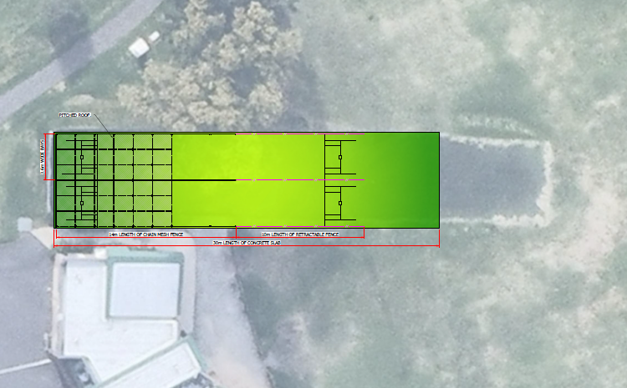

Project funding and timeframes
This project is funded through Council’s 2021/22 Cricket Practice Net Renewal Program. These works are proposed to commence in August 2021 and take up to 10 weeks to complete.
Will there be any changes to park usage because of the works?
Whilst works are taking place, the immediate areas will be made safe to ensure the safety of all park users. The community and sporting clubs will still be able to access and use the oval during this time.
Council will endeavour to cause minimal disruption to residents and park users during this time.
How can I keep informed?
For a project update or for further information please contact Luke Casey, Operations Coordinator on 9278 4444 or boroondara@boroondara.vic.gov.au.

